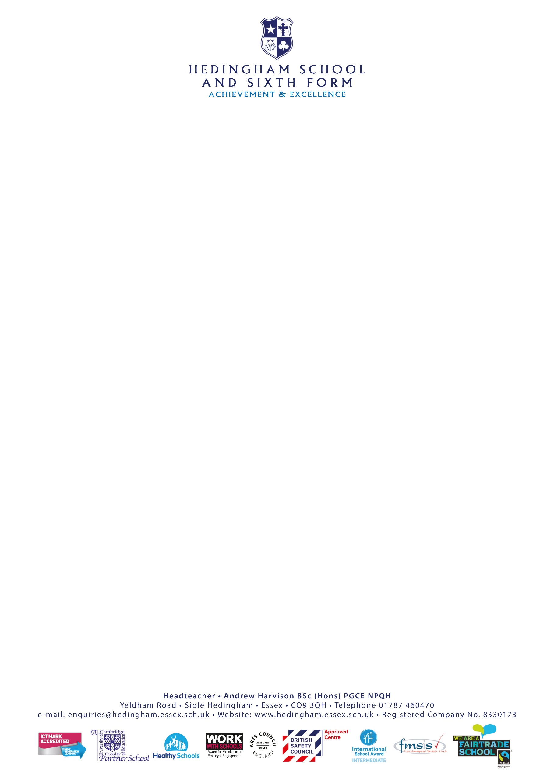

November 2023

Dear Parent/Guardian

The Jr. NBA League is coming to Hedingham School!

Boys and girls from Hedingham school will have the opportunity to play basketball in a Jr. NBA League organised by Basketball England in partnership with the NBA. The League will feature 30 school teams that will represent one of the 30 NBA teams throughout the season. The format will mirror the NBA including a team draft, regular season games, a single-elimination playoff and final to determine the Jr. NBA League Champion.

The school has been selected to represent the Golden State Warriors and we will have a new team kit to match theirs too!

To engage further with the league and stay connected we encourage you to download and register on OWQLO, the official App of the Jr. NBA Leagues. OWQLO has multiple functions including digital waivers that you must complete for your child to participate, scheduling, standings, and much more.
To find the waiver section in the OWQLO app please follow the steps below:

- Search for ‘OWQLO’ in your app store and register, be sure to verify your email
- Press ‘Explore’
- Press on ‘Competitions’ on the top
- Press ‘Enroll’ on the Jr. NBA League England
- Press ‘Enroll a Minor’ and follow the steps from there

In addition, the App enables players, coaches, and families to access exclusively created content. Further information about the OWQLO App can be found at www.basketballengland.co.uk/leagues/jr-nba/.

While you are there do not forget to create a free Basketball England account for your chance to win a trip to New York City to watch a live regular-season NBA game! Learn more at:
https://www.basketballengland.co.uk/news/join-basketball-england-and-win-a-trip-to-nyc-courtesy-of-the-nba/.

If you need any further information, please do not hesitate to get in touch.

Yours sincerely

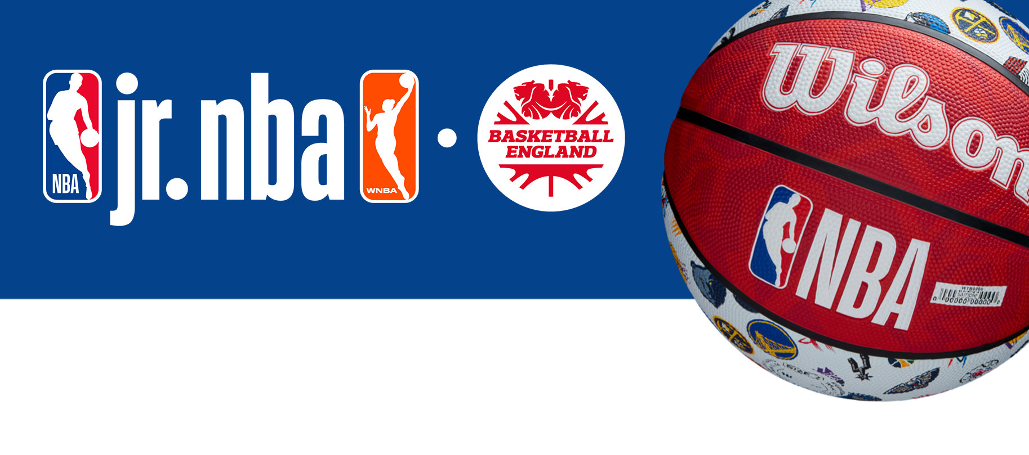
Mr C Kerr
Teacher of PE

