Examinations Handbook

2023 - 2024

Guidance for Students and Parents

Hedingham School

Centre Number 16519

Introduction

It is the aim of everyone at Hedingham School to make the examination experience as stress-free and successful as possible for all students.
Public examinations can be an extremely stressful time for students and parents alike. It is important that all those involved are as well informed as possible.
This booklet is intended to inform and advise students and parents and to help them to understand examination regulations and the procedures to follow in the event of any problems occurring.
Hedingham School will make every effort to ensure that candidates receive the best possible preparation for their examinations, that the administrative arrangements run smoothly, and that the examinations are conducted in a way that will cause as little stress as possible and help students to achieve their full potential. Mock exams are run to the same standards and rules in order that students are familiar with the process beforehand.
The Awarding Bodies (also known as Examination Boards) set down strict criteria that must be followed for the conduct of examinations and Hedingham School is required to follow them precisely. Particular attention should be paid to the Joint Council for Qualifications (JCQ) notices at the end of this document. These rules and regulations are designed to ensure fairness and minimise disturbance during exams and we are required to ensure that all candidates are made aware of them.
Some common questions are answered here but if there is any question that has not been addressed, please do get in touch.
After reading this booklet, if you have any further questions, please do not hesitate to contact our Examinations Officer:
Mrs Nina Powell
01787 460470
hed.powelln@hedingham.essex.sch.uk
On exams days it is best to contact the School Office on 01787 460470 and leave a message with the nature of your query or problem and we will get back to you as soon as possible.

Before the Examinations

Entries
Candidates will be issued a Statement of Entry. This should be checked carefully, paying particular attention to:
- Name – this should be the candidate’s full legal name. Check the spelling is correct.
- Date of birth
- Exam Entries – check that all the subjects you expect to take exams in are listed.
- Tier of entry – for certain GCSE subjects there will be a specific entry tier, either Foundation (F) or Higher (H). This relates to Mathematics, all the Sciences, French and German. Check that this tier is as you would expect.
Candidates will also be issued with their individual Exam Timetable. Again, please check this information carefully. The name and date of birth shown here will be printed on your final examination certificates. Awarding Bodies charge a fee to amend certificates which have already been issued.

Awarding Bodies
The school uses the following Awarding Bodies:
- AQA
- OCR
- Pearson (Edexcel)
- WJEC/Eduqas

Exam Regulations
The JCQ (Joint Council for Qualifications) oversees the examinations process in this country. Copies of the regulations and notices that they require candidates to be aware of are included at the end of this handbook.

Candidate Name & Candidate Number
Candidates must be registered using their legal names, not preferred or shortened names. Each candidate has a four digit candidate number. Students will write their name and candidate number on the front of their exam papers. To ensure that results are received smoothly and correctly, students should use their full legal name on the exam paper, not their preferred name. Each candidate has a card on their desk in the examination room displaying their legal name and candidate number. These cards must not be altered in any way by the candidate.

Timetables
Candidates will be issued with an individual timetable showing their own specific examinations with details of date, time and duration. These should be checked carefully and if anything appears to be wrong, the Examinations Officer should be notified immediately. You are responsible for knowing the dates and times of your exams.
Exams start at 9:00am and 1:00pm. You should arrive to the assembly area at least 15 minutes before the exam start time.

Contact Numbers
Please ensure that the school office has at least one up to date contact number for you.

Equipment
It is the responsibility of the candidate to bring the correct equipment with them. This is covered further, later in this document. The school is no longer selling pre-packed exam kits, however they can be purchased cheaply via Amazon for example, simply search for “Clear Exam Set”.

Calculators
You may use a calculator in an exam room unless prohibited by the Awarding Body’s specification Where the use of a calculator is allowed, you are responsible for making sure that your calculator meets the Awarding Body’s regulations.
Calculators must be:
- of a size suitable for use on the desk
- either battery or solar powered
- free of lids, cases and covers which have printed instructions or formulas
Calculators must not:
- be language translators
- be symbolic algebra manipulation capable
- be symbolic differentiation or integration capable
- be able to communicate with other machines or the Internet
- be borrowed from another candidate during the exam
- have retrievable information stored in them.
The use, or attempted use, of any such calculators will be regarded as malpractice and must be reported to the Awarding Body.

Student Availability
Students must be available to sit exams on the Awarding Bodies’ Contingency Dates. These dates will be used in the event of widespread national disruption to an exam or exams. The dates are:
- Thursday 6th June (pm only)
- Thursday 13th June (pm only)
- Wednesday 26th June (all day)

During the Examinations

Regulations
As soon as a candidate enters an examination room, they are under JCQ regulations.
There must be NO TALKING and no contact with other candidates. If assistance of any kind is needed, they must raise their hand and wait for an invigilator to come to them.
It is important to make sure that any of the restricted items have been removed from pockets/wrists BEFORE entering the room. Possession of these items in the exam room is malpractice and will almost certainly result in loss of marks for that paper even if the item was brought in by mistake and was not used. Further details of restricted items are in the FAQs later in this document.
MOBILE PHONES, WATCHES or any other electronic or storage device must not be taken into an examination room. If one is found in a candidate’s possession, even if it is switched off and was brought into the room by mistake, it will be taken from you and a report will be made to the Awarding Body. No exceptions can be made. Awarding Bodies take this regulation very seriously and they will almost certainly remove the marks for that paper from the candidate.
Candidate bags must not be taken into the exam room and will need to be left in siderooms. These rooms are not secure, candidates are advised to lock any valuable property in their lockers, or not bring it into school on examination days.
We do not accept any responsibility or liability for items left in school bags during examinations.
No food or drink can be taken into the exam room, with the exception of water, which must be in a clear, unlabelled, see-through bottle. Chewing gum is not allowed. If any other food or drink is required for medical reasons, this must be discussed with Nina Powell, Examinations Officer, before examinations start.
Candidates should:
- LISTEN carefully to instructions and notices read out by invigilators – there may be amendments to the examination paper that need to be understood.
- CHECK they have the right paper – check the subject, paper and tier of entry (where appropriate).
- READ instructions on the front of the examination paper carefully and follow them correctly.
- REMAIN seated in silence until told to leave the room.
- LEAVE in silence.
Candidates should not:
- DRAW graffiti, doodle or write comments on examination papers as the Awarding Body may refuse to accept them. This will result in a loss of marks for the student.
- REMOVE any items from pockets – make sure everything needed is on the desk before the examination starts.
- TAKE any questions papers, answer booklets or additional paper from the exam room.

Seating Plans
Seating plans will be displayed outside the main exam hall before each exam commences and are listed in Surname order. You should check the seating plan to ensure that you sit in the correct seat. It is essential that you sit in the correct seat for a specific exam or you may be given the wrong paper.

Invigilators
Invigilators are in the exam room to supervise the conduct of the examination. They will hand out extra paper if required and deal with any issues that arise, for example if a candidate feels unwell.
Candidates must follow all instructions given to them by invigilators at all times. Failure to do so constitutes candidate malpractice which must be reported to the Awarding Body and may result in loss of marks for that paper.
You are expected to behave in a respectful and polite manner towards the invigilators.
Please note that invigilators cannot discuss the exam paper at all. They cannot read out or explain the questions.
If the fire alarm sounds during an examination, candidates should remain seated and silent and follow the instructions given to them by the invigilators.

Exam Conditions
You are under strict exam conditions from the moment you enter the exam room until the time all candidates leave.
If you are using a laptop to type your exams you will still be under exam conditions until after you have printed and signed your typed exam paper.

At the End of an Exam
At the end of an exam, all work must be handed in. Remember to cross out any rough work.
If you have used additional sheets or answer booklets, put them inside the main answer booklet, in the correct order.
Invigilators will collect your question papers and answer booklets before you leave the room. Absolute silence must be maintained during this time. You are still under exam conditions until you leave the room.
Question papers, answer booklets and additional sheets must not be taken from the exam room.
You must remain seated in silence until you are told to leave. You must leave the room in silence, one row at a time, and show consideration to other candidates who may still be working.

Malpractice
Any form of malpractice, including possession of unauthorised material, even if by mistake, is a very serious offence and you will be subject to penalty and possible disqualification under the JCQ’s Suspected Malpractice Procedures.
Forms of malpractice include (but are not limited to):
- Being in possession of a prohibited device in the exam room, even if switched off. For example, mobile phone, watch etc.
- Being in possession of unauthorised materials, e.g. revision notes, dictionary etc.
- Communicating with other candidates, by talking, signing or otherwise
- Copying from other candidates
- Sitting an exam in the name of another candidate

Lateness
If you are running late you should get to the school as quickly as possible. If you can, call the School Office on 01787 460470 to inform us of the delay. When you arrive, go immediately to the exam room. You must not enter an exam room without permission after an examination has begun.
Hedingham School will do its utmost to ensure that you are able to sit the exam in the full allocated time. However, this may not always be possible.
If you arrive very late, the school must inform the Awarding Body, giving the reason and evidence for your lateness. This may result in you receiving no marks for that paper.
If you arrive after the end of an exam, you will not be admitted.

Absence
Any difficulties experienced during the exam period should be reported to the school at the earliest possible opportunity so that we can help or advise. This would include illness, injury, bereavement, personal problems etc.
Only in “exceptional circumstances” are candidates allowed special consideration for absence from any part of an examination. It is essential that signed medical or other evidence is obtained on the day and passed to the school immediately.
Please note that misreading the timetable is not a satisfactory explanation for absence from an exam.
If you are unable to attend an exam due to illness or some other serious reason, your parent/guardian must contact the School Office before 9:00am on the day of the exam.

After the Examinations

Notification of Results
Results will be released to candidates as follows:
GCE and other Level 3 qualifications: Thursday 15 August 2024
GCSE and other Level 1 and 2 qualifications: Thursday 22 August 2024
Timings for result release will be issued nearer the time.
If a candidate wishes any person other than themselves to collect results on their behalf, they must give written authorisation to the Examinations Officer before results day. The person collecting must provide photographic identification, such as a passport or driving licence.

Post Results
There will be members of the Senior Leadership Team and the teaching staff available on Results Days to give advice to students. Information about requesting a Review of Marking will also be available.

Certificates
Certificates will be available for collection by students from January 2025.
Please note: We do not post out certificates, they must be collected. This is due to the risk of them being lost in the post. Certificates are important legal documents and cannot be reissued. It is only possible to obtain a replacement statement of results from the Awarding Bodies and this incurs a significant cost.

Frequently Asked Questions

What do I do if there is a clash on my timetable? (This means you are due to sit more than one exam at the same time).
The Examinations Officer will be aware of this and you will be informed how this will be managed.
What do I do if I have an accident or am ill before the examination?
Inform the school as soon as possible so that we can help and advise you. There are many ways we can support you with different problems, for example, if you have an accident which means you cannot write, we can provide a word processor or a scribe who can write for you. We obviously need as much notice as possible to put these arrangements in place, but they can be organised at the last minute if necessary.
What do I do if I forget my candidate number?
Your candidate number is printed on your candidate card which will be on your desk when you arrive. Write this on the front of the exam paper when you are told to do so.
What do I do if I think I have the wrong paper?
The invigilator will ask you to check your paper before the examination starts. If you think something is wrong, raise your hand and tell the invigilator immediately.
What do I do if I forget the school centre number?
This will be clearly displayed in the exam room.
What do I do if I feel unwell during an examination?
Put your hand up and an invigilator will assist you.
If I am late, can I still sit the examination?
If you are late we may still be able to allow you to sit the examination, so even if you have missed the official start time you should still get to the school as quickly as possible.
If you are very late (as determined by the Awarding Body), they may decide not to accept your paper and you will not receive any marks for that paper.
If I miss an exam, can I take it on another day?
No.
Do I have to wear school uniform?
You must wear school uniform until you go on official study leave from school. After that you may wear whatever comfortable clothing you choose but hats and hoods must not be worn.

What equipment should I bring for my examination?
For most examinations you should bring:
- At least 2 pens – black ink only. These must not be of the erasable or gel ink variety.
- 2 HB pencils
- 30cm ruler
- Pencil sharpener
- Rubber
For some examinations you will need:
- A calculator
- A compass
- A protractor
- Coloured pencils
Your teachers will advise you on equipment prior to the examinations.
You are responsible for providing your own equipment for examinations. You must not attempt to borrow equipment from another candidate during the examination. If you find you have forgotten something, raise your hand and the invigilator will try to help.
What is allowed in the examination room?
Only material that is listed on question papers is permitted, so only bring what is needed for the specific examination. Your teachers can advise you.
You are allowed to bring water in a clear, see-through bottle with all labels removed.
If any other item is found in your possession, this has to be reported to the Awarding Body and you run the risk of losing your marks for that paper.
Why can’t I have my mobile phone in the exam room?
Awarding Bodies are very strict on this. Mobile phones, watches or any other electronic or storage device are not allowed in the room, even if they are in your pocket and switched off. If you are found with any of these items in the exam room, even if they are switched off, we will report it and the board will penalise you.
How do I know how long an examination is?
Your timetable tells you the length of the examination. It is also printed on the front of the paper. Start and Finish times are written on a whiteboard or large sheet of paper displayed at the front of the room. All rooms have clocks visible to all students.
Can I leave the room early if I have finished?
No as you will disturb those who have not finished. You must not leave the room until told to do so by an invigilator.
What do I do if the fire alarm goes off?
Stay calm, remain seated in silence – you are still under exam conditions. An invigilator will tell you what to do. You must follow their instructions.
Can I go to the toilet during an examination?
Yes. Raise your hand and wait for an invigilator, who will escort you.
What do I do if I do not get the grades I need/expect?
There will be members of the Senior Leadership Team and teachers available on Results Day to offer advice.
If you believe that it is necessary to make an enquiry about your result, you should first consult your teacher for that subject to obtain their advice as to the advisability of requesting a Review of Marking.
We have a very small window to make these requests so do not delay talking to your teacher.
When can we go on holiday after the exams finish?
All students are required to be available to sit exams on the Awarding Bodies’ contingency days which will be used in the event of national disruption to the exams this year. This means that you can plan to go away on holiday on or after 29th June.

JCQ On Your Exam Day Information
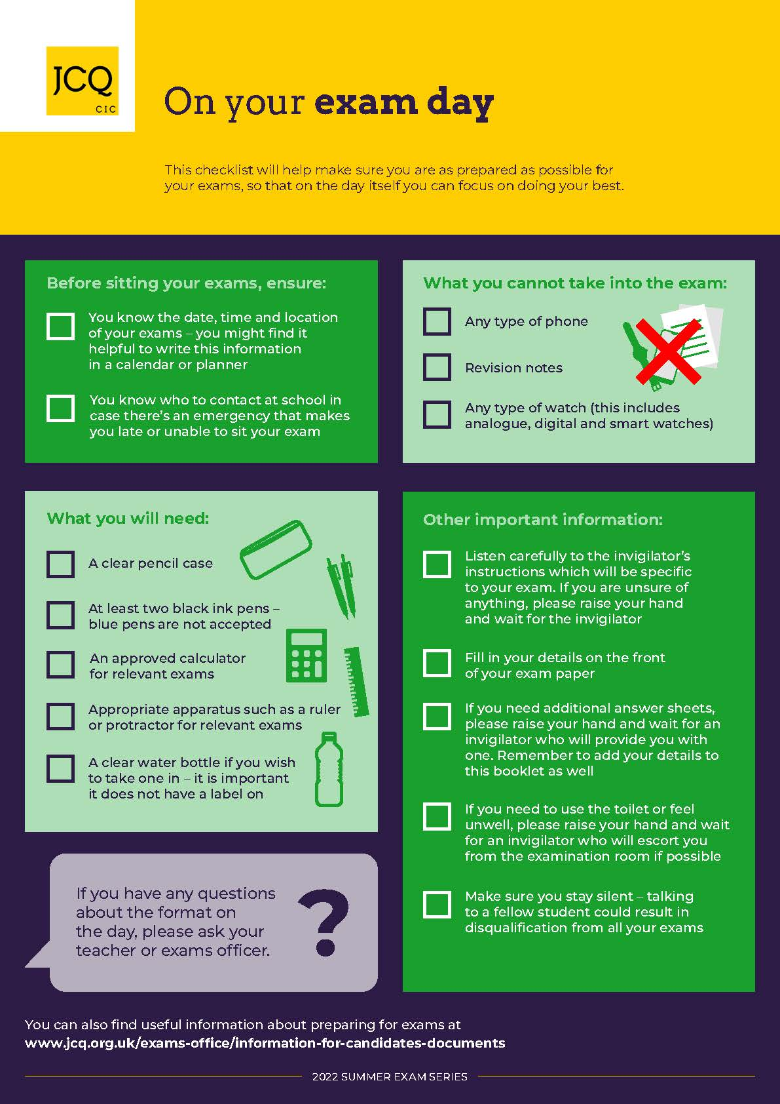

JCQ Warning to Candidates Poster

JCQ Unauthorised Items Poster

JCQ Information for Candidates – Written Examinations

JCQ Information for Candidates – Social Media

JCQ Information for Candidates – Non-examination Assessments

JCQ Information for Candidates – Coursework Assessments

JCQ Information for Candidates – On-Screen Tests

JCQ Information for Candidates – Privacy Notice

